BDSH Zen map (Nmap GUI) Report – Nmap example Scan.

This is a report for a network analysis from a team member of BDSH and does not include any AI analysis.
Contents
Summary report 1
Description of the network 2
Findings 2
Port 22 2
Port 53 3
Port 443 3
Port 80 3
Figures 4
Figure #1 - Table of Hosts and Associated Common Vulnerable Ports. 4
Figure #2 - Network topology 5
Figure #3 – Potentially a VPN. 6
References 6

Summary report
This network has 8 main hosts that are operating that we can see, and the rest were shown as available but were not scanned. What the items that were scanned showed is that there are a range of potentially vulnerable ports available on These available hosts that have been explored to potentially be vulnerable, however this is inconclusive and would require further analysis as current information is limited due to the scan type

Description of the network
This network scan shows a large array of different hosts; however, we have only been given the scans for 8 hosts with the remaining making up the majority of the network of which we do not have scans for and therefor can only make assumptions on these hosts.
From the looks of the topology however it looks as if the hosts that we do have access to are on the outer fringes of the network and could be the endpoints that are connected to the world wide web. These endpoints look as if they are routers and websites and potentially VPNs if we follow their streams. For example, if we look at Figure #3 (page 6) we can see that the network shows items two through six mention “PaloAlto.teleglobe.net” and “NewYork.teleglobe.net” which indicate to me that they could be used in some form of Virtual Private Network as they use the domain name Teleglobe which after a google search shows that they are a network provider, however this is unclear as we can only see the hosts names/IP addresses and not any critical information that might be provided by a more verbose scan and therefore we cannot come to any conclusions based off of these points. Similar findings can also be seen in other branches of the network.

Findings
For the machines on this network there are a few ports open that can be exploited, these vulnerable ports are generally Ports 22, 53, 80, 443. These Ports are potentially vulnerable for the following reasons:

Port 22
Port 22 is vulnerable because it is the Secure Shell (SSH) port which enables remote access and file transfer, this is a vulnerability because through remote access it also allows for brute force attacks which is where automated tools can execute thousands of logins attempts through this port.
Potential CVE:
In ssh-agent in OpenSSH before 10.5, some operations can occur remotely but were intended to occur only locally, including operations that add tokens or use keys. This is caused by mis interaction between agent locking and the session-bind@openssh.com extension.
CVSS:3.1/AV:N/AC:H/PR:L/UI:N/S:C/C:N/I:L/A:N
https://nvd.nist.gov/vuln/detail/cve-2026-73281

Port 53
Port 53 is the port that handles the domain name system queries and translates domain names into IP addresses for internet traffic. This system is vulnerable because nearly all traffic depends on DNS to function and therefor it is a high value target to attack. One of the common exploits for this port is to send small queries with spoofed source IP to open resolvers, the resolver returns large responses which overwhelm the network in unregulated volumes in a DDoS Attack.
Potential CVE:
Named in ISC BIND 9.x before 9.9.9-P5, 9.10.x before 9.10.4-P5, and 9.11.x before 9.11.0-P2 allows remote attackers to cause a denial of service (assertion failure and daemon exit) via a crafted DS resource record in an answer.
CVSS:3.0/AV:N/AC:L/PR:N/UI:N/S:U/C:N/I:N/A:H
https://nvd.nist.gov/vuln/detail/cve-2016-9444

Port 443
Port 443 is dangerous because it is a web port (HTTPs) that generally needs to be left open for organizations to operate, however most of the danger lies in the websites that operate on them rather than the actual port itself because while there is an encryption layer that protects the port from attacks, there is no such protections in the web pages unless implemented by the organization itself.

Port 80
Port 80 is vulnerable for the same reasons as 443 is and this is because it allows unsecure HTTP traffic to flow through it.
Potential CVE:
Double Free and possible RCE vulnerability in Apache HTTP Server with the HTTP/2 protocol. This issue affects Apache HTTP Server: 2.4.66. Users are recommended to upgrade to version 2.4.67, which fixes the issue.
CVSS:3.1/AV:N/AC:L/PR:L/UI:N/S:U/C:H/I:H/A:H
CVSS:3.1/AV:N/AC:L/PR:L/UI:N/S:U/C:H/I:H/A:H
https://nvd.nist.gov/vuln/detail/cve-2026-23918

Figures

Figure #1 - Table of Hosts and Associated Common Vulnerable Ports.
Host Name | Vulnerable ports
64.13.134.48 | 22, 53, 80
66.35.250.168 (freshmean.net) | 80
66.35.250.203 (sourceforge.net) | 80, 443
72.14.207.99 (eh-in-f99.google.com) | 80, 443
72.14.353.83 (po-in-f83.google.com) | 80, 443
199.185.137.3(cvs.openbsd.org) | 53, 80
204.152.190.12 (www.netbsd.org) | 22, 80, 443
204.152.191.37 (pub2.kernel.org) | 22, 80, 443

Figure #2 - Network topology
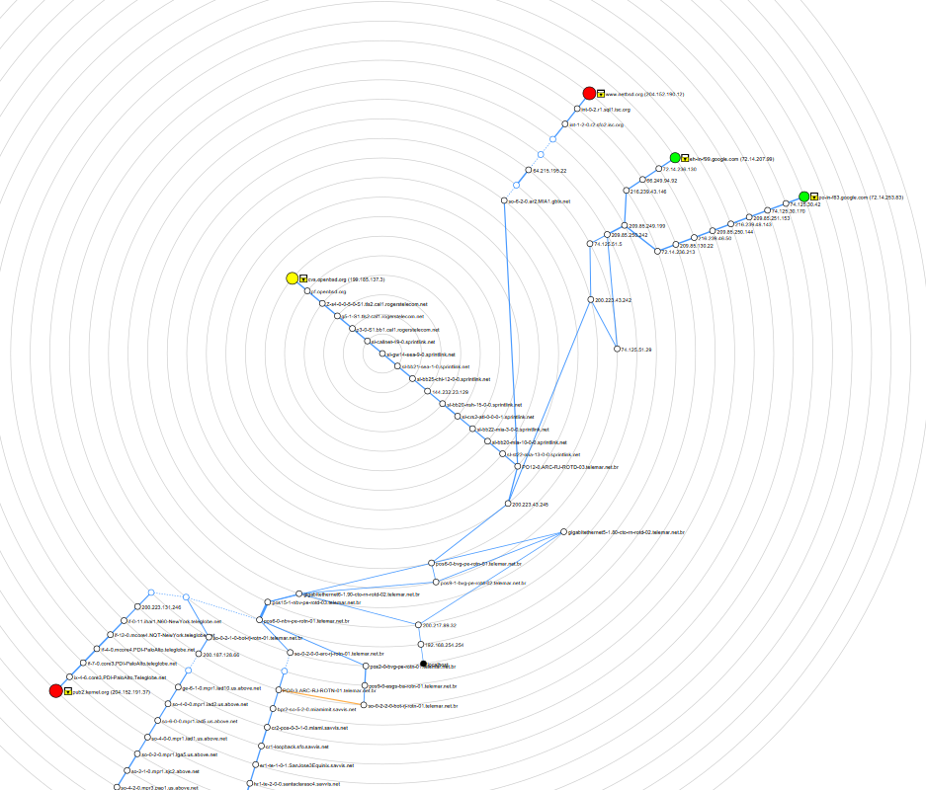

Figure #3 – Potentially a VPN.
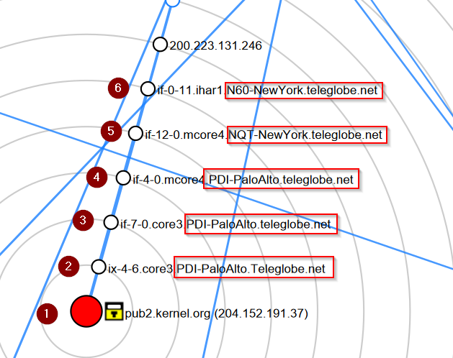

References
https://netwrix.com/en/resources/blog/open-ports-vulnerability-list/
https://securityscorecard.com/blog/navigating-the-risks-of-tcp-445-strategies-for-secure-network-communication/

This report took 1h 50m to make or ~2hrs

